Which tech tools are available during the summer for students?
*Watch your email for further updates
from EdTech*
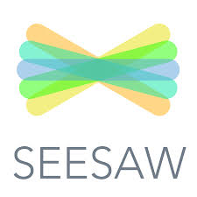  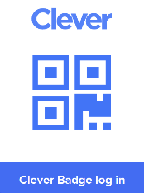  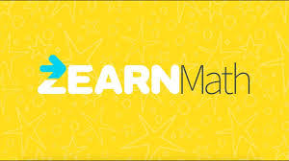 | Clever, Seesaw, & *Zearn will be accessible  through August 7th.  and will be inaccessible for most of August.  *Watch for any EdTech Updates in your email*
Rowena Duane (EL. Math TOSA) is working to see if students might actually have access to Zearn through the whole summer. Watch your email for updates!
Zearn is offering “summer recovery” programs to help make up for time lost with remote learning. They have them by grade level (you have to scroll down a little bit). Click here for to find those recommended lessons: https://about.zearn.org/learning-recovery?utm_campaign=learning-recovery&utm_medium=native&utm_source=whats-new
 | Lexia Core 5 will be available throughout the summer. Students will continue to be connected to their current (2019/20) classroom teacher.
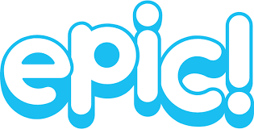
Epic Free Remote Student Access, via educator invitation, ends June 30, 2020. Starting July 1, all families who signed up for Remote Student Access will be able to enjoy a brand new service, Epic Free, which offers every student 2 hours of free weekly reading in a limited library of high-quality educational books.
* If you are an educator new to Epic or have not yet shared Remote Student Access with your families, it’s not too late! You can invite families to Remote Student Access through June 30, 2020. After that, you can invite families to Epic Free using the same instructions. Learn how to get started here. https://www.getepic.com/learn/introducing-epic-free/
ISD Elementary Librarians | The teacher librarians worked on getting a new e-book platform that is a one-stop-shop for all ebooks from Capstone, KCLS, and at least one other source.  It’s called SORA and will be added to everyone’s Clever for next school year.

